* Design TM using simulator to perform addition of ‘aa’ and ‘aaa’

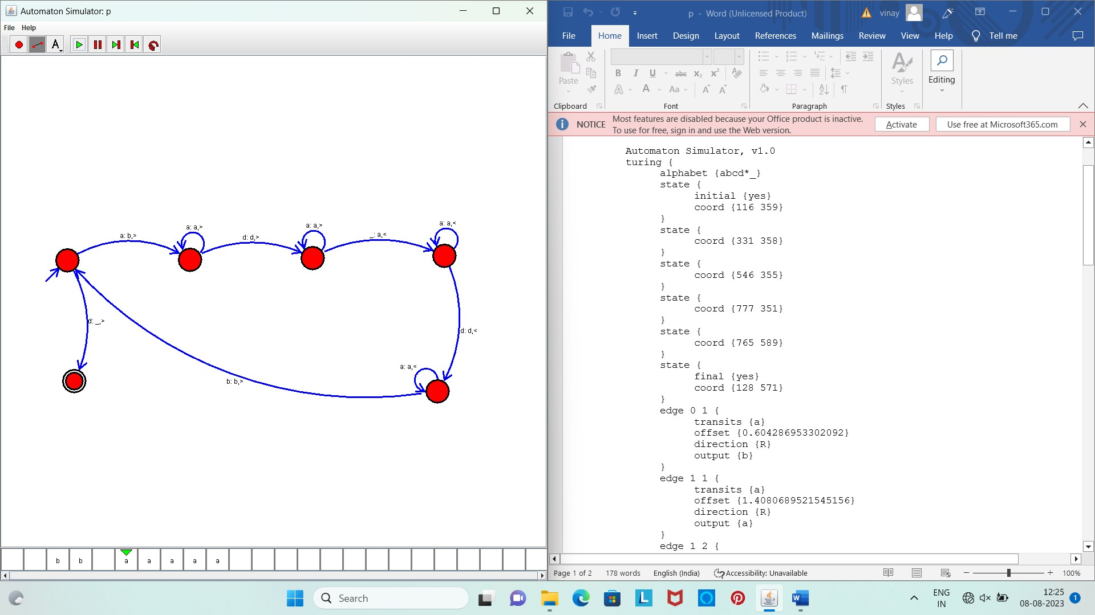

Result :

The simulator is accepted to perform addition for the strings of aa and aaa by using the above TM diagram